

**APPLICATION FORM FOR CONFIRMATION**

**PARISH PREPARATION PROGRAMME 2025-2026**

***The candidate should complete this form carefully IN FULL, please use BLOCK CAPITALS to ensure your writing is legible.***

NAME: …………………………………………………....................... Male/Female. *(Please circle)*

DATE OF BIRTH: ……………………………………………………....................................................

MY E-MAIL (case sensitive)…………………………………………………………………………….

MY MOBILE…………………………………………………………………………………………….

I AGREE TO BE IN THE CONFIRMANDI WHATSAPP GROUP I DO NOT AGREE

WhatsApp will be used to remind Candidates of meetings/Events. It is for Candidates and Catechists only.

PARENTS’ NAMES: …………………………………………………….................................................

ADDRESS: ………………………………………………………..............................................................

……………………………………………………......................................................................................

PARENTS MOBILE NUMBERS………….............………….....................................................................

PARENT’S E-MAIL(case sensitive)………………………………………………………………………

SCHOOL I ATTEND: …………………………………………….............................................................

CHURCH & PLACE OF BAPTISM - **FULL POSTAL ADDRESS**……………………………………...

……………………………………...........................………………………………………………………

………………………………………………………………………………………………………………

DATE OF BAPTISM……………………………........................................................................................

**Please attach a copy of your Baptismal certificate even if you were baptised in this parish.**

CHURCH WHERE YOU USUALLY WORSHIP:……………………….................................................

Enrolment on this course commits me to exploring my faith through participation in the parish Confirmation Programme and attending Sunday Mass. I will attend each session and promise to devote the necessary time and effort to the course.

Please **return this form** to the Parish Office **by the first meeting Tuesday 7th October 2025**

**Signed by the Candidate ……………………………………………………………………………………………**

**Signed by the Parent………………………………………………………………………………………………...**

You can find out more about how we use your data from our Privacy Notice which is available on our website [www.cbparish.com](http://www.cbparish.com/) and on the diocesan website [www.abdiocese.org.uk.](http://www.abdiocese.org.uk.)

**Please choose your Hoodie size**

Your size choice………………………………

Size S 35/37” M 38/40” L 41/43”Please circle the hoodie size you are ordering.



**CONFIRMATION PROGRAMME 2025-2026**

The candidates’ sessions take place on **Tuesday evenings at 7.30pm.**

Sessions will be in person at Bell Place, Bagshot. Sessions will be 1 ½ hours long. All candidates should be dropped off to and collected from the back door to the house at Bell Place. This can be accessed via the **black pedestrian gate on Freemantle Road**, **Bagshot** following the path round to the back door of the house. Candidates are expected to attend all dates below and each one is a compulsory part of the Confirmation Course.

Candidates will assist at Masses throughout the year at all churches at the dates which are provided below.

*The Mass of Confirmation will take place on a time and date to be confirmed.*

Please make a £50 per Candidate contribution towards the cost of the whole programme. Payment can be made via cheque made payable to The Camberley and Bagshot Catholic Parish for via Bank Transfer using the details on the Parish Website Donate Page [Donate | Camberley and Bagshot Catholic Parish (cbparish.com)](https://www.cbparish.com/financial-support). Please use your child’s Surname + CONF as the Payment Reference. This will help identify your payment. If you have any financial concerns please contact Fr Paul directly.

|  |  |  |
| --- | --- | --- |
| Tuesday | 7 October 2025 | Parents and candidates information session – St Peter and St John Church Hall 7.30pm |
| Tuesday | 14 October 2025 | Session 1 |
| Sunday | 9 November 2025 (Remembrance Sunday) | St Tarcisius  9.15 am Mass |
| Tuesday | 11 November 2025 | Session 2 |
| Sunday | 30th November 2025  1st Sunday of Advent | Christ the King  11.15am Mass |
| Tuesday | 9 December 2025 | Session 3 |
| Saturday | 20 December 2025 | The Nativity at Wintershall 5pm |
| Tuesday | 13 January 2026 | Session 4 |
| Saturday | 31 January 2026 (St John Bosco) | St Peter and St John  5.30pm Mass |
| Tuesday | 10 February 2026 | Session 5 |
| Sunday | 15 February 2026 | Pancake Sunday at St Tarcisius Hall |
| Friday | 27th February 2026 | 7-8.45pm Evening of Reflection with Bishop Richard at St Joseph’s church, Guildford |
| Tuesday | 10 March 2026 | Session 6 |
| Tuesday | 14 April 2026 | Session 7 |
| Tuesday | 12 May 2026 | Session 8 |
| Tuesday | 2 June 2026 | Social Event at Bell Place 7.30-9pm |
|  | ***2026 TBC*** | Rehearsal for Mass of Confirmation |
|  | ***2026 TBC*** | **Mass of Confirmation** |

Directions to Fr Paul’s House.

11 Bell Place

Bagshot

GU19 5NE

Tel. 01276 476356

Top of Form

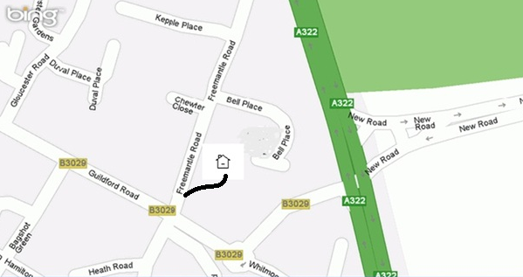

Footpath

Once in Bagshot and travelling along the Guildford Road, you will pass Christ the King church on the right hand side, then turn into Freemantle Road on the left hand side. Just before the bus stop.

Immediately park up on the left. (Please note there is insufficient parking on Bell Place.)

Look for a single black metal gate. This can be found on the right hand side of the road approximately 25 yards from the Junction of Guildford Road and Freemantle Road. Go through the gate and follow the private pathway to Fr Paul’s Home.

Ring the bell if necessary

Parents must accompany their child to the door and collect from the door. Thank you.